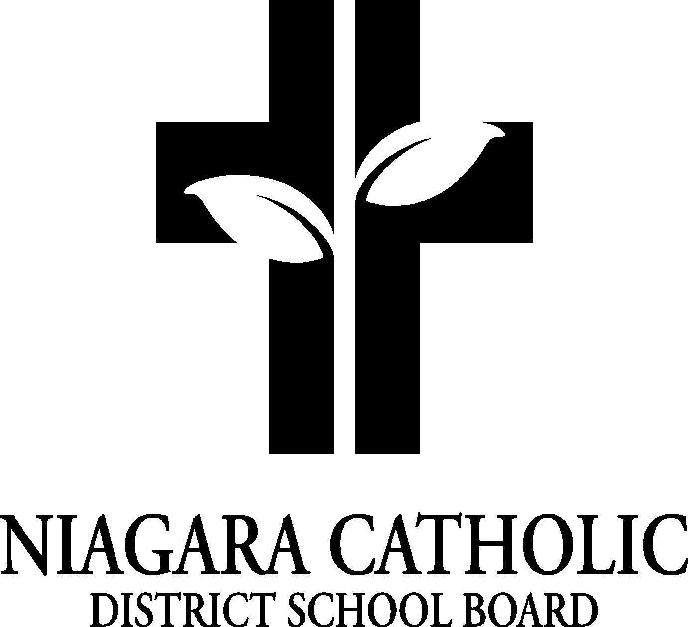

MINUTES OF THE
St. John Henry Newman CATHOLIC SCHOOL COUNCIL MEETING

September 29, 2020
Virtual

Minutes of the Meeting of the St. John Henry Newman Catholic School Council, held on Tuesday September 29, 2020 at 6:00 p.m..

The meeting was called to order at 6:00 p.m. by Chair /Co-Chair Jessica Petrella and Silia Stapleton

A. ROUTINE MATTERS

1. Opening Prayer

The opening prayer was led by Paolo Sirianni

2. Roll Call

CATHOLIC SCHOOL COUNCIL MEMBERSHIP |  | Present | Excused | Absent
Principal/Vice-Principal  Secretary/Treasurer | Paolo Sirianni (Acting Principal)  Julie Mangiacasale (Vice-Principal & Secretary)  Maria Elia (Treasurer) | 
Chair | Jessica Petrella  Silia Stapleton
Co-Chair(s) | Jessica Petrella  Silia Stapleton
Teacher Representative | Marre Gray
Non-Teaching Representative
Student Representative
Parish Representative | Jose Evangelista  Kelly Fiala  Marie Kowalczyk
Community Representative | Marie Kowalczyk  Rochelle Horwath  Lyndsay Shura
OAPCE Representative  NPIC | Marilyn Fabiano
PARENT/GUARDIAN MEMBERS
Safe and Accepting School Committee: Phyllis DeProphetis, Kelly Fiala, Silia Stapleton
Jessica Petrella
Silia Stapleton
Phyllis Deprophetis
Sonia Taddeo
Lindsay Shura
Maria Elia
Kelly Brown-Fiala
Katie Bender
Barbara Perone

Jose Evangelist
Marilyn Fabiano
Rochelle Howarth
Ann-Marie Abbruscato
Ludmilla Morretto
Luisa Carbonara
Marre Gray
Marie Kowalezyk

3. Approval of the Agenda

Moved by Paolo Sirianni
Seconded by Silia Stapleton
THAT the St. John Henry Newman Catholic School Council approve the Agenda of the St. John Henry Newman Catholic School Council Meeting of Tuesday September 29, 2020.
CARRIED

4. Disclosure of Conflict Interest

No disclosures of conflict of interest were declared with any items on the agenda.

5. Approval of Minutes of the St. John Henry Newman Catholic School Council Meeting of Tuesday September 29, 2020

Moved by First meeting of the year, therefore no minutes to be approved.

- PRESENTATIONS: Faith Formation – Mr. Tham’s Grade 8 class created a virtual opening school Liturgy
- Virtual School Masses to follow from Our Lady of the Scapular
- How do we incorporate Rosary Club in the school without people coming into the school?
- ECO Team: Thank you to all those who were able to assist with maintaining our school gardens throughout the summer!
- Anyone who is able to assist with gardens before winter, your assistance is greatly appreciated

- Food Days: Possible sub day to begin introducing food days back into the school
- 6” inch sub at a cost of $6.00 – comfortable price
- Subs will be divided up by class and delivered to each class with tongs provided for the teacher to hand out subs
- Possible first date Oct. 23rd
- Fundraising Ideas: Purse Bingo, Purse and something else to broaden our attendance, Virtual Raffle, Spring Outdoor Movie Night with concessions, Gift Baskets with seasonal masks/hand sanitizers etc. as gifts

- Grade 8 Graduation class of 2020: Club Italia Celebration scheduled for Oct. 8th Cancelled!
- Waiting direction from the Board for graduation direction
- We will be booking Club Italia for this coming Spring for our Grade 8 Grads 2021

- Confirmation: will take place with family member restrictions
- Waiting for more details from the Church

- First Holy Communion: If child did prepare last year, just show up to the church on Sunday 15 min. before mass and identify to Father that you are there to receive First Holy Communion
- Your child can wear their communion dresses and suits
- Current Grade 2’s wishing to receive First Holy Communion, parents must go to the church office to pick up preparation package
- The church will give you a time in the spring

- Journey’s: Will not be overnight and is being redeveloped

- Student Council: Co-Prime Ministers will be announced this week
- Students applied for a variety of positions
- All students who are interested will be involved

- Breakfast Club: Niagara Nutrition Partners is piloting snack program “Grab and Go”
- Provide each class with labelled bins and tongs with prepackaged snacks that the teacher can hand out
- Follow-up with Local Farmers to provide fresh fruit for October

- Food Drives: Out of the Cold and Soup Kitchen
- Can drop off food
- Jose to provide contact information

- Clothing/Shoe Drive: Donate items left in lost and found from last year
- Soles for Souls

- Backpacks of Hope: TBD

- Christmas Shop: On hold

- Picture Day: On hold

- School Yard Equipment: Look into purchasing colour coded balls for each division and discuss how to roll out the use of equipment and cleaning of equipment for health and safety

- School Messenger: App is challenging – will check into

- Halloween: We will have costumes
- No Costume Masks
- No exchange of treats
- No Costume Accessories
- Will discuss parade with staff
- COVID Check: Parents/Guardians remember to sign into Permission Click which verifies that parents/guardians will be responsible for accessing your child’s health/symptoms each day

- Newsletter: Newman News Weekly update will replace the monthly newsletter

- Calendars: Will include important upcoming dates and events on the back

- October 9th: St. John Henry Newman Day!

- Parent Volunteers: Currently we are not having volunteers in the school
- Will send out information as we receive it
- Consider reviewing your Vulnerable Sector Check to ensure it is current and ready

- POLICIES FOR VETTING-

- PRINCIPAL’S REPORT

- Niagara Catholic Parent Involvement Committee (NCPIC) – Nothing to report
- Special Education Advisory Committee (SEAC) –Nothing to report
- Catholic School Council Financial Statement: Current CSC balance is $7944.60 purchased 18 chrome books at the end of last year
- School Updates: Cardinal Newman’s name has officially been changed to St. John Henry Newman
-Celebration for school name change TBD
-Big Bear Uniforms has updated our Logo
-Name change on the gym wall TBD

- OAPCE REPORTS: No report

- STAFF REPORTS: No report

- AGENDA ITEMS-DISCUSSION FOR FUTURE MEETINGS: Fundraising ideas, Food days, Triathlon fundraiser (reschedule for Feb. Valentine’s Day Raffle

- NEXT MEETING: November 17th @ 6:00 p.m. (virtual)

- CLOSING PRAYER was led by Paolo Sirianni

- ADJOURNMENT
Moved by Paolo Sirianni
Seconded by Julie Mangiacasale
THAT the Tuesday September 29th meeting of the St. John Henry Newman Catholic School Council be adjourned.
CARRIED

This meeting was adjourned at 7:30 p.m.

